# Connecting to VPN

**NOTE: Virgin by default have a VPN blocker set on their routers. Call them up beforehand and tell them to disable it so that I can connect to work network from home**

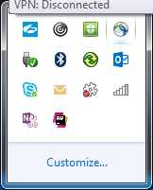

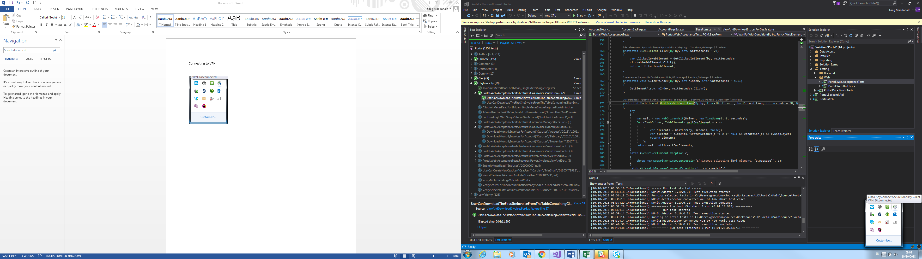

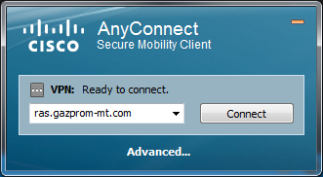

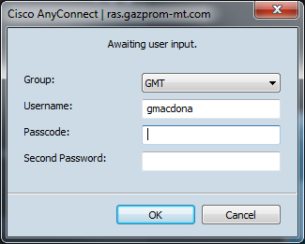

Go to token app on phone. Enter PIN (mum B’day)

Enter long number on app into Passcode field

Enter normal windows password into Second Password field

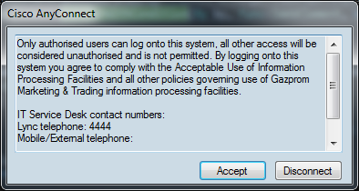

Click on Accept

To Disconnect: Right click on



And select VPN Disconnect